**VISVESVARAYA TECHNOLOGICAL UNIVERSITY**



MINI PROJECT REPORT ON

**“RAIN SENSOR”**

SUBMITTED BY:

**SANJAY D E (1NH19EC406-T)**

**PADMAVATI (1NH19EC411-T)**

**NAYANKUMAR K C (1NH19EC412-T)**

Under the guidance of

**RAJASHREE**

Assistant Professor/Senior Assistatant Professor/Associate Professor/Professor, Dept. of ECE, NHCE, Bengaluru.

# C:\Documents and Settings\Students\Local Settings\Temporary Internet Files\Content.Word\download (1).jpg

# NEW HORIZON COLLEGE OF ENGINEERING

(ISO-9001:2000 certified, Accredited by NAAC ‘A’, Autonomous college permanently affiliated to VTU)Outer Ring Road, Panathur Post, Near Marathalli, Bengaluru-560103

## NEW HORIZON COLLEGE OF ENGINEERING

## DEPARTMENT OF ELECTRONICS AND COMMUNICATION ENGINEERING



**CERTIFICATE**

Certified that the mini project work entitled “**Title**” carried out by **SANJAY D E (1NH19EC406-T), PADMAVATI (1NH19EC411-T), NAYANKUMAR K C (1NH19EC412-T),** bonafide students of Electronics and Communication Department , New Horizon College of Engineering, Bangalore.

The mini project report has been approved as it satisfies the academic requirements in respect of mini project work prescribed for the said degree.

Project Guide HOD ECE

------------------------- -------------------------

**External Viva**

Name of Examiner Signature with Date

1.

2.

**ACKNOWLEDGEMENT**

The satisfaction that accompany the successful completion of any task would be, but impossible without the mention of the people who made it possible, whose constant guidance and encouragement helped us succeed.

We thank **Dr. Mohan Manghnani**, Chairman of **New Horizon Educational Institution**, for providing necessary infrastructure and creating good environment.

We also record here the constant encouragement and facilities extended to us by **Dr.Manjunatha**, Principal, NHCE and **Dr. Sanjeev Sharma**, head of the department of Electronics and Communication Engineering. We extend sincere gratitude to them.

We sincerely acknowledge the encouragement, timely help and guidance to us by our beloved guide .**RAJASHREE**  to complete the project within stipulated time successfully.

Finally, a note of thanks to the teaching and non-teaching staff of electronics and communication department for their co-operation extended to us, who helped us directly or indirectly in this successful completion of mini project.

**SANJAY DE (1NH19EC406-T)**

**PADMAVATI (1NH19EC411-T)**

**NAYANKUMAR K C (1NH19EC412-T)**

**TABLE OF CONTENTS**

ABSTRACT

**CHAPTER 1**

INTRODUCTION…………………………………………………………………………………7

**CHAPTER 2**

LITERATURE SURVEY………………………………………………………………………… 8

**CHAPTER 3**

PROPOSED METHODOLOGY…………………………………………………………………..10

**CHAPTER 4**

PROJECT DESCRIPTION ………………………………………………………………………..12

4.1 HARDWARE DESCRIPTION……………………………………………………………….22

4.2 SOFTWARE DESCRIPTION…………………………………………………………………25

**CHAPTER 5**

RESULTS AND DISCUSSION…………………………………………………………………26

**CHAPTER 6**

CONCLUSION AND FUTURE SCOPE …………………………………………………………27

REFERENCES…………………………………………………………………………………….28

APPENDIX………………………………………………………………………………………..29

**LIST OF FIGURES**

|  |  |  |  |
| --- | --- | --- | --- |
| **SL**  **No** | **FIGURE**  **No** | **FIGURE DESCRIPTION** | **Page**  **No** |
| 1 | 1.1 | Block diagram of rain alarm | 8 |
| 2 | 1.2 | Rain water sensor |  |
|  |  |  |  |
|  |  |  |  |
|  |  |  |  |

### LIST OF TABLES

|  |  |  |  |
| --- | --- | --- | --- |
| **SL**  **No** | **Table**  **No** | **TABLE DESCRIPTION** | **Page**  **No** |
| 1 | 1.1 | Resistor colour coding | 14 |
|  |  |  |  |

**ABSTRACT**

In this project we have a tendency to tried to gift the essence of conservation of rain water. the most purpose of this project is to gather clear rain water mechanically mistreatment water detector. The rain water detector is wont to conserve water, forestall groundwater and waterways pollution, to save cash on plant food. The rain alarm circuit produces associate degree perceptible alarm whenever the rain falls. The rain detector circuit relies on 2 transistors and also the probes.

**CHAPTER 01**

**INTRODUCTION**

Water is a basic need in every one’s life. Saving water and correct usage of water is extremely necessary. Here is a simple project which can provide the alarm once there's rain, so we are able to build some actions for rain water gathering and additionally save the rain water for victimization it later.

With the help of saving this rain water through rain water harvesting, we can increase the levels of underground water by using underwater recharge technique.

Rain water detector will detect the rain and make an alert; rain water detector is used in the irrigation field, home automation, communication, vehicles etc. Here is that the straightforward and reliable circuit of rain water detector which may be made at low value.

**CIRCUIT DIAGRAM**

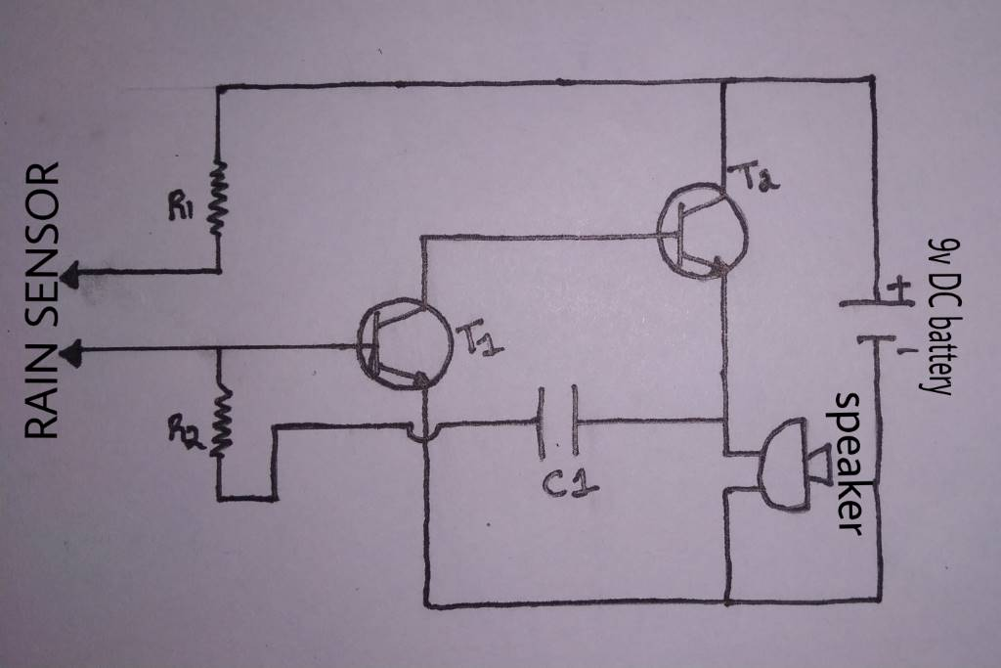

**CHAPTER 02**

**LITERATURE SURVEY**

Rain alarm is device it will really work how we needed what you need to do. This is a device it will generate the signal when there is a raining outside. When there is heavy rain the frequency is more and frequency is less when rain is less.

This is nothing but frequency is depend upon rain. When rain starts circuit will generate sound/music

**RAIN WATER SENSOR**

A rain sensor is a switching device it is activated by drop of the rainfall. There is two main applications for rain sensors. The first is a water conservation device is connected to an automatic irrigation system it will causes the system to switch of when there is rainfall. And another one is a device it is used to protect the interior of the automobile from rain and to make support to the automatic mode of windscreen wipers.

In this project/circuit rain sensor is the main component . for this sensor, no need to go for the market to buy this project. You can do it your self by taking the components and make the connection to the PCB board use some alluminium wire

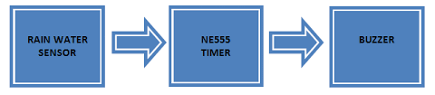

**IRRIGTION SENSOR**

Irrigation system in rain alarm is available in both wired and wireless version, both wired and wireless project use similar mechanisms watering by irrigation controller specially rain sensor is connected to the sensor terminal of irrigation controle , common circuit prevents the frequency of any value when rain is sensed

**CHAPTER 03**

**PROPOSED METHODOLOGY**

We all have a growing intrest to do the project, we fallow many ways to make the project to get the output.

We use mobile internet or department laboratory to do the first phase of project that is mostly theoretical part.in this case we need internet connection to find the related information about the project

In the second phase is we use the department laboratory to represent the project by equipments we use electronic lab

**CHAPTER 04**

**PROJECT DESCRIPTION**

**CAPACITOR**

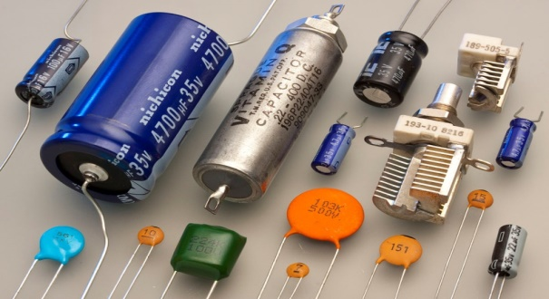

A electrical condenser may be a device that stores electricity in an electrical field. it's a passive electronic element with 2 terminals.

The impact of a capacitance is understood as capacitance. whereas some capacitance exists between any 2 electrical conductors in proximity during a circuit, a capacitance could be a part designed to feature capacitance to a circuit. The capacitance was originally called a condenser or condensator. This name and its cognates ar still wide employed in several languages, however seldom in English, one notable exception being condenser microphones, conjointly known as capacitance microphones.

The physical form and construction of practical capacitors vary widely and many types of electrical condenser area unit in common use. Most capacitors contain a minimum of 2 electrical conductors usually within the kind of gold plates or surfaces separated by a stuff medium. A conductor could also be a foil, thin film, forge bead of metal, or associate degree solution. The nonconductive stuff acts to extend the capacitor's charge capability. Materials unremarkably used as dielectrics embody glass, ceramic, sheet, paper, mica, air, and chemical compound layers. Capacitors area unit wide used as components of electrical circuits in several common electrical devices. in contrast to a resistance, a perfect electrical condenser doesn't dissipate energy, though real-life capacitors do dissipate atini low quantity. (See Non-ideal behavior once an electrical potential, a voltage, is applied across the terminals of a electrical condenser, for instance once a electrical condenser is connected across A battery, an electrical field develops across the stuff, inflicting a internet electric charge to gather on one plate and internet charge to gather on the opposite plate. No current truly flows through the stuff. However, there's a flow of charge through the supply circuit. If the condition is maintained sufficiently long, the present through the supply circuit ceases. If a time-varying voltage is applied across the leads of the electrical condenser, the supply experiences associate degree current current because of the charging and discharging cycles of the electrical condenser

The earliest sorts of capacitors were created within the 1740s, once European experimenters discovered that electrical phenomenon might be hold on in water-filled glass jars that came to be called metropolis jars. In 1748, pressman connected a series of jars along to form what he referred to as associate degree "electrical battery", from their visual similarity to battery of cannon, that became the quality English term battery. Today, capacitors area unit wide employed in electronic circuits for obstruction electricity whereas permitting electrical energy to pass. In analog filter networks, they sleek the output of power provides. In resonant circuits they tune radios to explicit frequencies. In electrical power transmission systems, they stabilize voltage and power flow.[2] The property of energy storage in capacitors was exploited as dynamic memory in early digital computers.

**RESISTOR**

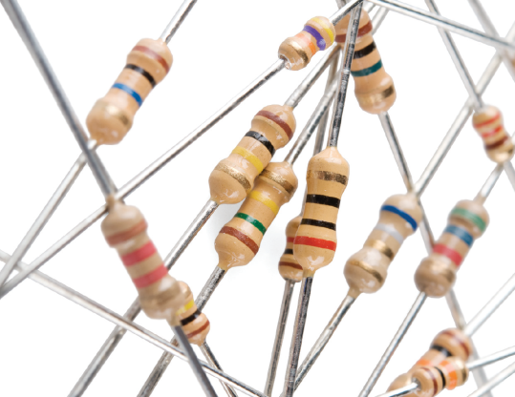

Resistor is a  passive two-terminal electrical component that implements electrical resistance as a circuit element. In electronic circuits, resistors are used to reduce current flow, adjust signal levels, to divide voltages, bias active elements, and terminate transmission lines, among alternative uses. high-octane resistors which will dissipate several watts of electric power as heat, could also be used as a part of motor controls, in power distribution systems, or as check masses for generators. fastened resistors have resistances that solely modification slightly with temperature, time or operative voltage. Variable resistors are often accustomed change circuit parts (such as a volume management or a lamp dimmer), or as sensing devices for warmth, light, humidity, force, or chemical activity.

Resistors is common elements in electrical networks and also in electronic circuits and they are ubiquitous in electronic equipment. Practical resistors are discrete components it can be composed of various compounds and forms. Resistors also are enforced at intervals integrated circuits.

The electrical operate of a resistance is specified by its resistance: common industrial resistors ar factory-made over a variety of quite 9 orders of magnitude. The value of the resistance falls at intervals the producing tolerance, indicated on the element.

**Ohm’s law**

Ohm’s law states that current flowing through a conductor is directly propotional to the voltage applied to the ends of the conductor

Ohm’s law states voltage across the resistor is directly proportional to the current where the constant proportionality of an resistance. For example, if a 300 ohm resistor is attached across the terminals of a 12 volt battery, then the current of 12 / 300 = 0.04 amperes flows through that resistor.

Practical resistors are also have some inductance and capacitance which are affect the relation between voltage and also current in alternating current circuits.

The ohm is an SI unit of electrical resistance, named after Georg Simon Ohm. ohm is equivalent to an volt per ampere. Since resistors are specified and is manufactured over a very large range of values, the derived units are milliohm (1 mΩ = 10−3 Ω), k ohm (1 kΩ = 103 Ω), and mega ohm (1 MΩ = 106 Ω) are also in common usage.

**RESISTOR COLOUR COADING**

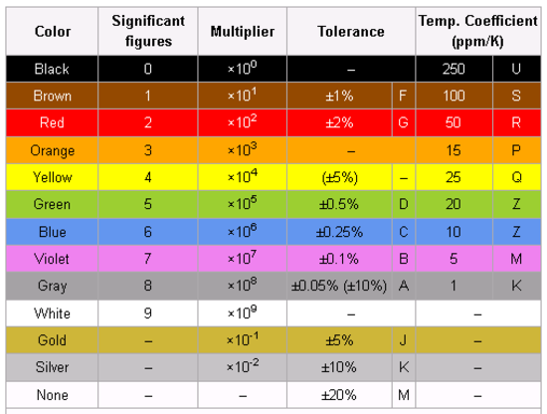

[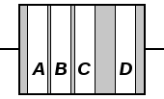](https://en.wikipedia.org/wiki/File:Resistor_bands.svg)

[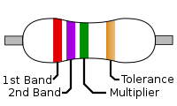](https://en.wikipedia.org/wiki/File:4-Band_Resistor.svg)

To identify colour code left from right there is a gap between the C and D bands.

1. The first significant figure of component value (left side)
2. The second significant figure (some precision resistors have a third significant figure, and thus five bands).
3. The decimal multiplier
4. If present, indicates tolerance of value in percent

In the above example, there is a resistor with bands of red, violet, green, and brown has first digit 2 (red; see table below), second digit 7 (violet), followed by 5 (green) zeroes: 2700000 ohms. Gold signifies that the tolerance is ±5%.

Resistors are manufactured for military use it may also include a fifth band which indicates a component’s failure rate; refer to -199 for the further details.

Tight tolerance resistors may have three bands for significant figures is rather than two, of an additional band indicating temperature coefficient, in units of ppm/k.

In All coded components they have at least two value bands and a multiplier other bands are optional.

Resistors are uses various E-series of preferred a numbers for their specific values, which are determined by their a tolerance. These values are repeat for every decade of magnitude: ... 0.68, 6.8, 68, 680, ... For the resistors of 20% tolerance the E6 series, with six values: 10, 15, 22, 33, 47, 68, then 100, 150, ... is used; each value is approximately for the previous value is multiplied by 6√10. For the 10% tolerance of resistors that is E12 series, with 12√10 as multiplier, is used; similar schemes up to the E192, for 0.5% of tighter tolerance is used. then the separation between these values is related for the tolerance so that adjacent values at the extremes of tolerance approximately is just overlaped; for example, in the E6 series 10 + 20% is 12, while 15 − 20% is also 12.

0 ohm resistors, marked with a single black band, are lengths of wire wrapped in a resistor-like body which can be mounted on the printed-circuit board (PCB) by automatic component-insertion of equipment. These are typically used on PCB’s as insulating "bridges" where two traces are there otherwise cross, like as soldered-in jumper wires for setting configurations.

The "body-end-dot" or "body-tip-spot" system was used for the cylindrical composition of resistors sometimes still there found in there very old equipment; then the first band was given by the body colour, for there second band by the colour of there one end of the resistor, and the multiplier by a dot or band around the middle of the resistor. For the other end of the resistor is there in the body color, silver, or gold for 20%, 10%, 5% tolerance

**TRANSISTOR**

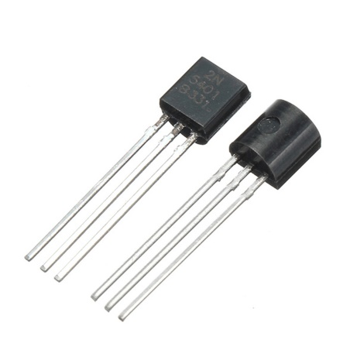

A transistor is an semiconductor device which is used to amplify or switch the electronic signals and also electrical power. It is a composed to an semiconductor material usually with at least three terminals for the connection are to the external circuit. An voltage or current applied to the one pair of the transistor's terminals controls of the current through another pair of the terminals. Because these controlled (output) power may be higher than the controlling (input) of an power, then a transistor can amplify a signal. Today, some of the transistors are packaged individually, but many more transistors are found embedded in integrated circuits.

Austro-Hungarian physical Julius edge lilienfeld projected the idea of a field impact semiconductor device within the year 1926, however it absolutely was inconceivable to really construct a operating device at that point. the primary operating device to be designed {fet|field-effect semiconductor device|FET|transistor|junction transistor|electronic transistor} was some extent contact transistor fabricated within the year 1947 by yank physicists Bardeen and conductor Brattain whereas operating beneath physicist within the Bell Labs. They shared the 1956 Nobel prize in Physics for his or her accomplishment. the foremost wide used semiconductor device is MOSFET (metal–oxide–semiconductor field-effect transistor), are called the MOS semiconductor device, it absolutely was was fabricated by Egyptian engineer Muhammad atalla is with Korean engineer Dawon Kahng at Bell Labs in 1959. The MOSFET was the primary actually compact semiconductor device that would be miniaturised and factory-made for a good vary of uses.Transistors revolutionized the field of electronics, and paved the way for smaller and cheaper radius, calculators, and conjointly computers, among different things. the primary electronic transistor and also the MOSFET square measure on the list of IEEE milestones in physics. The MOSFET is that the basic building block of contemporary electrical devices, and is present in trendy electronic systems. Associate in Nursing calculable total of thirteen sextillion MOSFETs are factory-made between 1960 and 2018 (at least ninety nine.9% of all transistors), creating the MOSFET is that the most generally factory-made device in history.

Most transistors area unit made up of terribly pure atomic number 14 material, and a few from element, however bound different semiconductor materials may be used. A electronic transistor could have only 1 reasonably charge in there carrier, in an exceedingly FET, or could have 2 sorts of charge carriers in bipolar semiconductor device (BJT) devices. Compared with associate degree thermionic tube, transistors area unit typically terribly tiny in size, and need less power to control. bound vacuum tubes have benefits over transistors at terribly high operational frequencies or high operational voltages. many sorts of transistors area unit created to standardized specifications by multiple makers

**RAIN SENSOR**

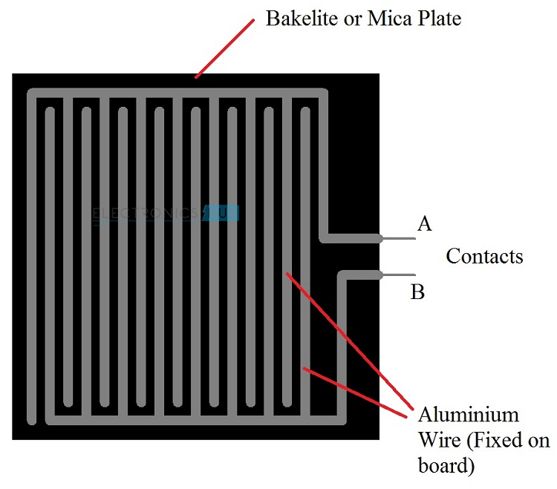

A rain detector or rain switch could be a shift device activated by downfall. There area unit 2 main applications for rain sensors. the primary could be a conservation device connected to associate degree automatic irrigation system that causes the system to pack up within the event of downfall. The second could be a device accustomed defend the inside of associate degree automobile from rain and to support the automated mode of windshield wipers. a further application in skilled satellite communications antennas is to trigger a rain blower on the aperture of the antenna feed, to get rid of water droplets from the plastic cowl that keeps pressurised and dry air within the wave-guides.

**Automotive sensors:**

In 1958, the Cadillac Motar automobile Division of General Motors experimented with a water-sensitive switch that triggered numerous electrical motors to shut the convertible prime and lift the open windows of a specially-built El Dorado Biarritz model, just in case of rain. the primary such device seems to own been used for that very same purpose in an exceedingly idea vehicle selected LE Sabre and designed around 1950–51.

General Motors' automatic rain sensing element for convertible super was offered as a dealer-installed possibility throughout the Nineteen Fifties for vehicles like the Chevrolet Bel Air.

For the 1996 Model Year, Cadillac all over again equipped cars with associate automatic rain sensor; this point to mechanically trigger the screen wipers and alter their speed to conditions as necessary.

In December 2017 Telsa started rolling out associate degree OTA update (2017.52.3) enabling their cars to utilize the aboard cameras to passively find rain while not the utilization of an obsessive device.

Most vehicles with this feature have associate degree "AUTO" position on the management column.

**Physics of rain sensor:**

The most common fashionable rain sensors ar supported the principle of total internal reflection. in any respect times, associate degree infrared radiation is beamed at a 45-degree angle into the windscreen from the inside. If the glass is dry, the incidence angle for total internal refraction is around 42°. This worth is obtained with the overall internal refraction formula

**PCB board:**

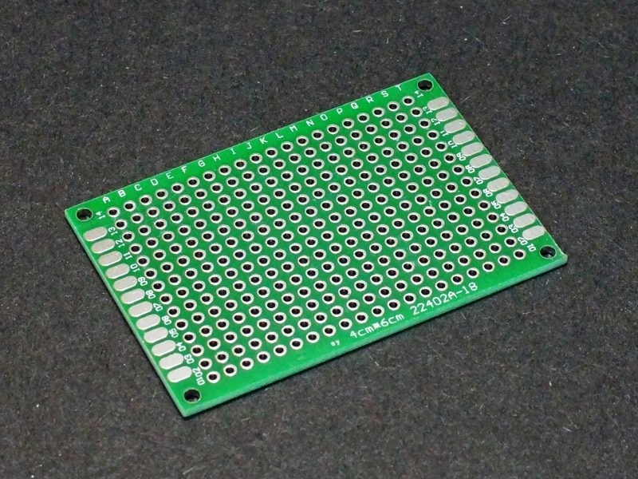

A printed circuit board (PCB) automatically supports and electrically connects physics elements or electrical elements mistreatment Semiconductive tracks, pads and alternative options carved from one or additional sheet layers of copper laminated onto and/or between sheet layers of a non-Semiconductive substrate. elements square measure usually soldered onto the PCB to each electrically connect and automatically fasten them to that

Printed circuit boards square measure utilized in well-nigh the only electronic product. they're conjointly utilized in some electrical product, like passive switch boxes. Alternatives to PCBs embody wire wrap and purpose to purpose construction, each once in style however currently seldom used. PCBs need further style effort to get out the circuit, however producing and assembly will be machine-driven. specialised CAD package is out there to try to to abundant of the work of layout. Mass-producing circuits with PCBs is cheaper and quicker than with alternative wiring strategies, as elements area unit mounted and wired in one operation. giant numbers of PCBs will be made-up at an equivalent time, and therefore the layout solely has got to be done once. PCBs may also be created manually in little quantities, with reduced advantages.

PCBs can also be single-sided (one copper layer) or double-sided (two copper layers on each side of 1 substrate layer), or multi-layer (outer and inner layers of copper, alternating with the layers of AN substrate). Multi-layer of a PCBs ar allowed for abundant higher part of density, as a result of circuit traces of on the inner layers would otherwise take up surface area between elements. the increase in quality of multilayer PCBs with quite 2, and particularly with quite four, copper planes was coinciding with the adoption of surface mount technology. However, multilayer PCBs build repair, analysis, and field modification of circuits way more troublesome and typically impractical.

The world marketplace for blank PCBs exceeded $60.2 billion in a pair of 014.In 2018, the worldwide Single Sided computer circuit Board market research Report calculable that the PCB market would reach 79 billion by 2024.

**Over view:**

A basic PCB consists of a flat sheet of insulant and a layer of copper foil, laminated to the substrate. Chemical etching divides the copper into separate conducting lines referred to as tracks logic gate traces, pads for connections, vias to pass connections between layers of copper, and options like solid semiconducting areas for magnetism shielding or alternative functions. The tracks operate as wires fastened in situ, and ar insulated from one another by air and also the board substrate material. The surface of a PCB might have a coating that protects the copper from corrosion and reduces the possibilities of solder shorts between traces or unsought contact with stray vacant wires. For its operate in serving to to stop solder shorts, the coating is named solder resist or solder mask.

A computer circuit board will have multiple copper layers. A two-layer board has copper on each sides; multi layer boards sandwich further copper layers between layers of insulation. Conductors on totally different layers ar connected with that ar copper-plated holes that perform as electrical tunnels through the insulating substrate. Through-hole element leads typically conjointly effectively perform as vias. once two-layer PCBs, succeeding boost up is sometimes four-layer. usually 2 layers ar dedicated as power offer and ground planes, and therefore the different 2 ar used for signal wiring between elements.

"Through hole" elements ar mounted by their wire leads passing through the board and soldered to traces on the opposite aspect. "Surface mount" elements ar hooked up by their ends up in copper traces on a similar aspect of the board. A board could use each strategies for mounting elements. PCBs with solely through-hole mounted elements ar currently uncommon. Surface mounting is employed for transistors, diodes, IC chips, resistors and capacitors. Through-hole mounting is also used for a few giant elements like electrolytic capacitors and connectors.

**BURZER:**

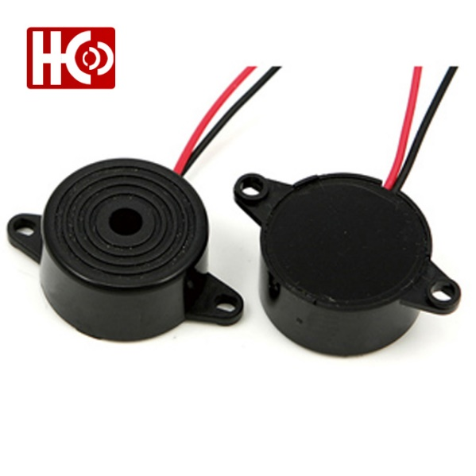

A buzzer or electronic device is associate degree audio signalling device, which can be mechanical, mechanical device , or electricity (piezo for short). Typical uses of buzzers and beepers embody alarm devices, timers , and confirmation of user input like a depression or keystroke.

**TYPES**

**Electromechanical**

Early devices were supported AN mechanical device system clone of an electrical bell while not the metal gong. Similarly, a relay could also be connected to interrupt its own activating current, inflicting the contacts to buzz. typically these units were anchored to a wall or ceiling to use it as a sounding board. The word "buzzer" comes from the rasping noise that mechanical device buzzers created.

**Mechanical**

A joy buzzer is associate example of a strictly mechanical buzzer and that they need drivers. alternative samples of them area unit doorbells.

**Piezoelectric**

A electricity component is also driven by associate periodical electronic circuit or alternative audio signal supply, driven with a electricity audio amplifer. Sounds unremarkably wont to indicate that a button has been ironed area unit a click, a hoop or abeep.

**CHAPTER 05**

**RESULT AND DISCUSSION**

**CHAPTER 06**

**CONCLUSION AND FUTURE SCOPE**

As nearly everything represented already for this style, we might wish to say there ar still varied styles of enhancements one will implement on this project to form it even additional convenient. The project we've created and given is sort of economical and it's value effective additionally. it's nice advantage of over the optical device covering all the planning specifications beside the necessity of commoner. the essential maneuvering is finished solely to form it value effective and reliable.

**REFERENCES**

[1] www.google.co.in

[2] about circuit-basic electronic equipment function

[3] Wikipedia-www.wikipedia.org

[4] http//seminarprojects.net/rain sensor project

**APPENDIX**

1. within the irrigation, it'll notice the rain and straight off alert the farmer.
2. In vehicles, once the rain detector detects the rain it'll straight off active the wipers and inform the driving force.
3. In communications, it'll boost the ability of the antenna and increase the signal strength to send or receive the signals.
4. In traditional house hold, with the assistance of rain water detector we will mechanically save the rain water. (This are often done only if home automation is finished and there's correct instrumentation to avoid wasting the rain water. In this, rain water noticeor can detect the rain and helps to change ON the instrumentation which is able to mechanically save rain water for various purposes).
5. this may even be used if there's a chemical rain additionally. this is often quite common in industrial areas.